SOLO ENGLISH CHANNEL SWIM

CREW BOOK

CONTENTS

GENERAL INFORMATION

PRE-SWIM (BEFORE THE DAY)

PRE-SWIM (ON THE DAY)

SWIM

POST SWIM

GENERAL INFORMATION

Objectives of this pack

- To be clear on who does what and when – Before, during and after the swim. For the swim to be a success EVERY role and task is important.

- Like everything about Channel Swimming things constantly change. If circumstances change before or during the swim you may need to pick up other tasks, so please review the whole document.

- There's a lot to remember and consider. This is my plan, based on what I know at this time. Through this plan you will be more aware of my preferences on key points. Things may occur on the day that are no in the plan, feel free to adapt as required to ensure the swim can be successful.

- Each of you need to be clear on what your part of the plan is and when each action is required. The clearer the plan the more chance we have of succeeding

- If you don’t understand something then ask, if you don’t agree with something then ask, if it doesn’t make sense then ask.

- You win or you learn, let’s make sure we do the learning now, so we win on the day.

GENERAL INFORMATION

The Swim

In a straight line, it is 21 miles or 33.5km. The tide will mean that the swim takes the shape of a ‘S’ curve. This extra distance is travelled, not swum. The swim is only ever from point to point.

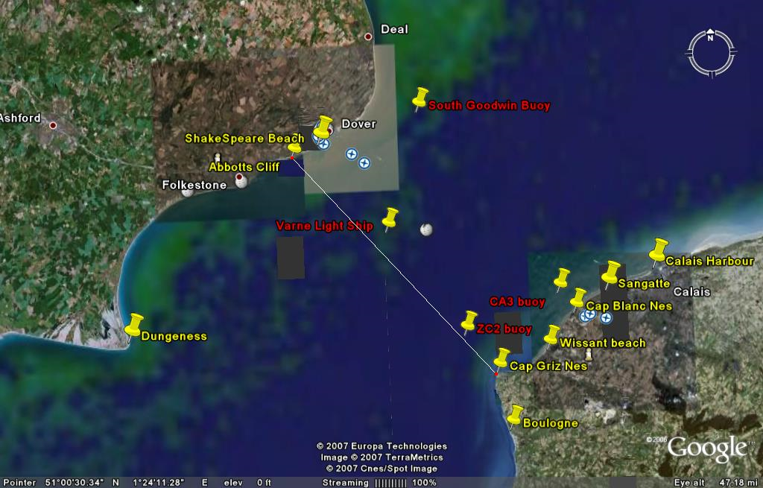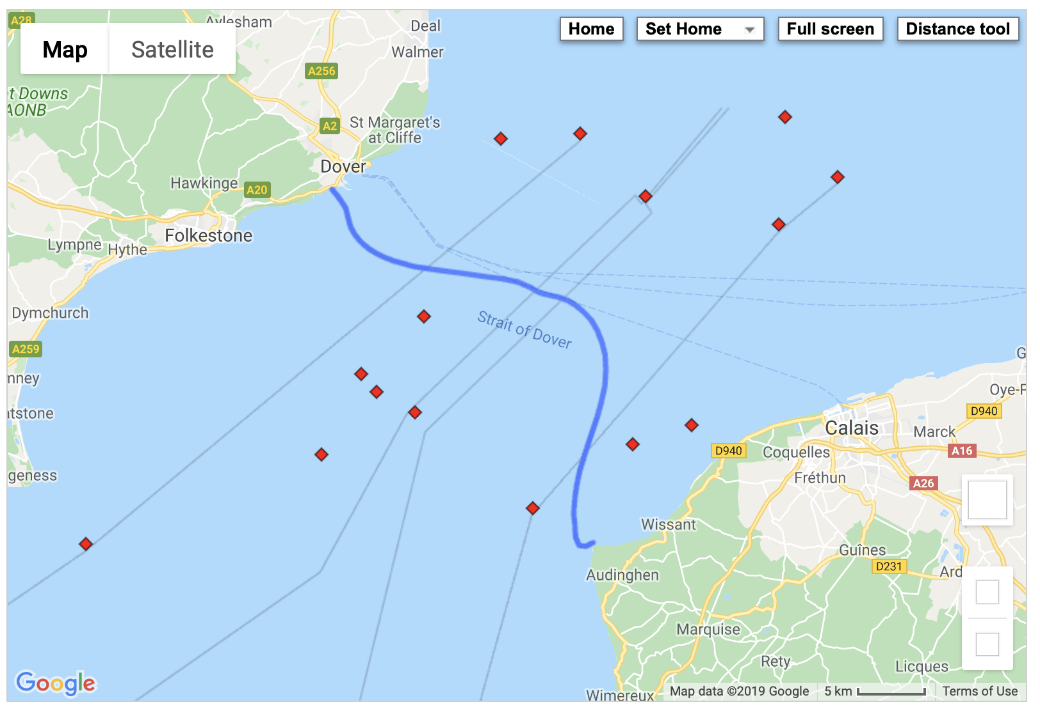

The pilot will decide where the swim starts, Shakespeare Beach or Samphire Hoe. The closest point is Cap griz Nez, but it could be anywhere along the coastline (lots of swims land in or around Wissant).

GENERAL INFORMATION

Pilot & Boat
Picture of your pilot boat
Picture of your pilot

\

Pilot Name
- Landline number: xxxxx xxxxxx
- Mobile number: xxxxx xxxxxx
- Email: name@email.com

Boat information
- Passengers & crew: 12
- Category: 2 (2 = 60 miles from port)
- Based in Dover / Folkestone
- Fitted with somewhere to charge phones / cameras, laptops etc
- X bunks, a toilet and a gas hob for hot water
On the boat
- Pilot (Name) – Responsible for navigation and swimmer safety – his decision is final
- Pilot crew (Name) – Works under [pilot] and enables [pilot] to have rest breaks. Same authority as pilot
- Observer – Observes the swim to ensure all rules are complied with

Your team
[Name 1] – number – primarily responsible for feeding and communicating with swimmer
[Name 2] – number – primarily responsible for help getting ready, support swimming, updating social media, help after swim
[Name 3] – number – primarily responsible for capturing the day in photos / videos
[Swimmer] – number – only responsibility is to swim until he / she runs out of water. Keep crew informed of any issues (e.g. pain) or any feeding requests.
[Partner / emergency contact] – name & number

NB, adjust crew numbers & responsibilities accordingly – 1-3 is optimal number. Some contracts restrict number of crew – check your contract or with your pilot.

GENERAL INFORMATION

Channel Swimming Association (CSA) Requirements for the Boat (similar is true for the CS&PF)

Accommodation and aftercare: There must be a means of supplying hot water and sheltered accommodation where the Swimmer can lie down and receive attention. Provision must be made for the Swimmer's condition to be checked and observed at regular intervals after the Swim has finished. Shelter should also be available for the Observer, and Trainer/assistants.

Navigation Equipment: In addition to the statutory safety equipment, the Pilot Vessel must be equipped with Radar, GPS and AIS.

First Aid: In addition to the Statutory Medical Kit and T.P.A's, Torch, etc. vessels must always carry spare Blankets or Sleeping Bags and rescue blankets, (gold/silver rescue sheets in case of hypothermia), Anti-Histamine cream (for stings) and Sea sickness tablets. Oxygen should only be carried or used by competent personnel.

Recovery Equipment: A Harness or some other Lifting Device suited to the Vessel and the prevailing conditions must be provided to recover a distressed or unconscious Swimmer from the water, (preferably in a horizontal position).

Ladder: A ladder, which extends well below the water line when in position, must be rigged or positioned ready for use at all times during the Swim. Pilots are requested always to have a crew man on standby to assist the swimmer entering or exiting the water.

PRE-SWIM (before the day)

Travel & Accommodation
 | Date 1 | Date 2 | Date 3
Hotel | Name & address details

Notes:
- I hope to be swimming between x and y which is the window I have been given. I will be the 1/2/3/4/5th swimmer who goes with my pilot in this window. This is completely weather dependent. There may be some long-range information, however, the final decision will be made after the 7pm weather forecast the night before. Where you live will determine whether you and your crew need to travel to Dover in advance. If you are close enough to travel once the swim has been confirmed, this is also an option.
- Most B&Bs require payment up front, whether you stay or not. Most hotels can be cancelled up to 1pm on the day of arrival.
- [Name] will drive [swimmer] down to Dover, [Crew] will get the train down and we can pick him up or taxi from station. [Name] will drive down.
- I have made provisional hotel bookings for us all as above. I would like / do not need everyone to be in Dover the night before the swim. It is likely to be late when we get back. Decide whether you want a team meal before the swim. After the swim you are welcome to stay or head home, whatever you prefer.
- Travel details for partner / family / kids etc
- [Name] will manage and change the bookings if required.

NB – swimmer should pay for all accommodation and meals for their crew. Swimmer should not stay alone after the swim (risk of delayed onset of issues like SIPE).

PRE-SWIM (before the day)

The Swim & Tides use http://cspf.co.uk/tide-tables to complete the table
Tide | Low | High | Low | High | Sun  Rise/ Set
Date –  day 1 | XX:XX | XX:XX | XX:XX | XX:XX | XX:XX
 | X.XM | X.XM | X.XM | X.XM | XX:XX
Date –  day 2 | XX:XX | XX:XX | XX:XX | XX:XX | XX:XX
 | X.XM | X.XM | X.XM | X.XM | XX:XX
Date –  day 2 | XX:XX | XX:XX | XX:XX | XX:XX | XX:XX
 | X.XM | X.XM | X.XM | X.XM | XX:XX
Date –  day 2 | XX:XX | XX:XX | XX:XX | XX:XX | XX:XX
 | X.XM | X.XM | X.XM | X.XM | XX:XX
Date –  day 2 | XX:XX | XX:XX | XX:XX | XX:XX | XX:XX
 | X.XM | X.XM | X.XM | X.XM | XX:XX
Date –  day 2 | XX:XX | XX:XX | XX:XX | XX:XX | XX:XX
 | X.XM | X.XM | X.XM | X.XM | XX:XX

- The swim is likely to start 1-2 hours before high water. We would need to be at the boat approx. 1 hour before this.
- This will ideally be the early morning tide but depending on weather/ wind etc it could be the late afternoon tide – we should be prepared for both
- As at today (date) there are x more swimmers to go in front of me. If the weather is good for the rest of the week we go xx. If one of them has a bad weather day or the day after them is bad, then it could be later.
- If a swimmer decides to go early or cancels, then I could swim earlier than anticipated.
- If the tide finishes without a swim, I go to the back of the list for future tides. Therefore, it would be useful to understand your availability outside of this tide window.
- We will have hotel rooms booked for the night before as the previous page.
- Sun rise is xx:xx which means I’ll likely have x hours of swimming in the dark at the beginning. Sunset is xx:xx so any swim over x hours will have a finish in the dark.

PRE-SWIM (before the day)

What needs to be done

Food Preparation
- By [2 days ahead]: All crew to confirm to Swimmer any special requests for the day. Ideally, things that are easy to eat and require minimal preparation
- Day before or day of swim: Swimmer to purchase and package all food and bottled water in crew crate
- Day before or day of swim: Swimmer to prepare and pack all [Swimmer’s] food and drink in swimmer crate. [Crew 1] / [Crew 2] / [Crew 3] to review night before swim

Clothes and Other Items
- By [2 days ahead]: Swimmer to prepare own kit and place in bag. [Crew 1] / [Crew 2] to review night before swim
- By [2 days ahead]: [Crew 2] to prepare swim kit and place in separate bag including towel, anything required for getting out. [Crew 2] to review with [Crew 3] night before so he/she can assist him/her.
- By [2 days ahead]: All crew to prepare day bag, suggested items on following page. Dry bags are useful, depending on boat, but not essential.
- By [2 days ahead]: Swimmer to pack first aid kit including basic items, sea sickness tablets (all should test these in advance to make sure they agree with them), Imodium and pain killers

PRE-SWIM (before the day)
Packing

Each of you needs to bring your passport in case we are boarding by the French or English coastguard.
In addition, you may want to consider packing the following:
- Sun hat – Whilst you are on deck you will be exposed to the sun. Even the boats that have indoor / covered areas are likely to mean the swimmer can’t easily see you.
- Warm clothes – It can get very cold at sea. Think about layers and things you can take off / on easily
- Waterproof jacket and trousers
- Sandals or beach shoes – your feet will get wet
- Torch – useful when looking for things from the crates / bags in the hours of darkness. A head torch might be a good idea – though be cautious not to shine it directly in the eyes of the swimmer. The pilot will want his cabin to remain dark to ensure his night vision, so minimise any light pollution during the dark.
- Sunglasses
- Towel
- Sun cream
- Shorts and t-shirt for good weather and spares just in case

There’s an art to bringing enough but not too much. The more ‘stuff’ we bring on board, the less room there is for people to rest. Everything needs to be taken off the boat again afterwards.

PRE-SWIM (on the day)
Packing

When we board the boat, we will have the following. The swimmer should not carry anything heavy onto the boat to avoid any last-minute injuries.

- 1 crate containing my food, drinks and spare swim equipment that I may ask for during the swim
- 1 crate containing all the Crew food and drink, first aid kit and whiteboard (*).
- [Swimmer] kit bag containing towel, clothes, dry robe etc.
- 3 x crew kit bags, 1 for each of you with your clothes etc.
- 8 x 1.5 litre bottles of drinking water for mixing feeds / creating hot water
- 24 0.5 litre bottles of drinking water for crew use

* Check with your pilot about the use of whiteboards. Some like them, some don’t. They can be an efficient way to communicate when the swimmer’s hearing is impacted by earplugs and water, but if the swimmer slows down to read the messages it can be detrimental to the swim.

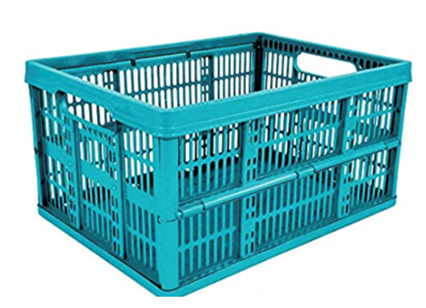
NB – ensure then swimmer leaves their watch on board

PRE-SWIM (on the day)

- As already, mentioned we will need to arrive at the harbour 1 hour before I am due to swim.

- Before we leave the hotel / home, I will need to apply suncream. [Crew 1] to help with my back.

- On arrival in Dover [Crew 2] to go to the harbour office and pay for 24 hour parking. You’ll need to quote the boat name. If you are leaving from Folkestone, please check the required arrangements.

- All crew to take all crates and bags to boat.

On board boat
- [Swimmer] sort goggles, cap and ear plugs, get undressed to Dryrobe, hat and Crocs.
- [Crew 1] to put clothes into bag so he knows where they are on completion. These should be in the order they will be put back on later.
- [Crew 2] to apply grease and put lights on
- If the swim starts from Shakespeare beach, the above should start immediately. It takes about 20 minutes to get to Samphire Hoe, so there is longer if that is the start location. However, it makes sense to be ready early provided there is no risk of getting cold if the air temperature is low.
- Earplugs, hat & goggles can be left until when we’re close to the start. It is important to avoid any contact with grease when putting goggles on. If in doubt clean them. Grease on goggles will lead to leaks and / or inability to see well.
- After I have jumped in [Crew 2] to put my crocs and Dryrobe into my swim bag.

SWIM
Rules

- Traditional swimwear only (not beyond hipline for CSA, can be down to knee for CS&PF), one swim hat, earplugs & goggles. Support swimmers can wear anything they want!
- I must be completely clear of the water before the start. The swim starts when I enter the water. The observer will record the start time and location.
- There can be no contact with me during the attempt. I cannot touch another person or the boat. Feeds can be passed to me. The observer will record everything that is consumed and how long the stops are.
- To finish I must clear the water or touch the rocks of a rock face (or be told to do so for safety). If I am accompanied in, I must clear the water before anyone else. Don’t touch me before I’m clear!! It doesn’t matter how I exit the water; crawling is fine. Note – if it’s a long stretch of shallow water, it’s generally quicker and easier to swim than walk - feel free to remind me!
- The observer will record the finish time and location.
- The CSA will require a doping check after the swim. The CS&PF may request a sample for checking.

SWIM
Swimming in the dark (if required)
- It is likely that some part of the swim will be in the dark.
- Most boats have lights that can be seen from the water (insert details for your boat here). Some boats give you the choice to have the spotlight on or off.
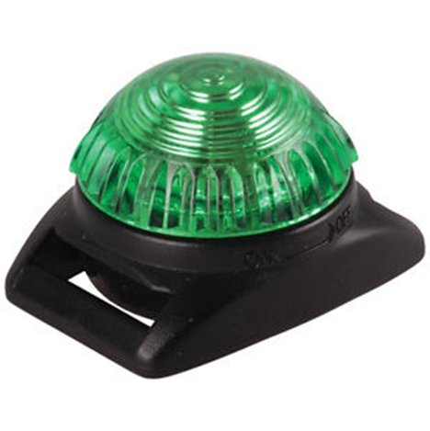
- I will be wearing [clear / reactor] goggles at night-time and [will / will not] need to change them as the light changes. Remember to wear clear goggles for night swimming. If you wear reactor lens goggles, then check whether these react to the boat spotlight. Wearing tinted goggles in the dark makes keeping a good line almost impossible.
- I will be wearing two green lights (check if this is the preferred colour of your pilot). One will be set to flash and will be on the back of my goggle straps. The other will be static and will be attached to the back of my costume. By having one flashing and one static, you’ll always be able to work out which direction I’m swimming in. If it’s light when I start and they need to be switched on, then I’ll ask for confirmation that they are working.
- Throughout the swim one of you should be watching me at all times, in the dark it is even more important as it can feel lonely when you can see less. If you wear lightsticks I’ll be more able to see you. Please also put chemical lightsticks along the sides of the boat (under the gunnels so that it doesn’t impact the pilot)
- For feeding in the dark – attach a lightstick to the feed so that I can see it. NB this depends on light levels on yoru boat. Some won’t require this.
- I breath bi-laterally so can swim on either side of the boat. My preference is to swim on the left of the boat. The pilot’s preference is for me to swim on the [left / right] of the boat. I’ll swim about 5-10m from the boat.
- I may need to change and move to the [left / right] side if the boat if the weather conditions change. The pilot will advise.

SWIM
Feeding Instructions – These are the most important pages! [Crew 1] to lead but [Crew 2] can provide support / advice

- Feeding needs to be quick otherwise I will drift with the tide. A few extra minutes can add hours to the swim time and can mean the difference between success and failure. So, I need you to be prepared and slick!
- Follow the attached feeding schedule – if I want something different, I will let you know at the feed before to give you time to prepare.
- The pilot may make suggestions based on how I am swimming, please take the advice.
- If you feel you need to change anything else about the plan to achieve success, then please do so. That could be what’s in the feeds or frequency. Please ask the pilot for advice if you are unsure.
- You need to signal to me 5 mins before each feed [chosen signal]. I will signal back with a thumbs up.
- You need to time it and tell me when I have to move – 30 seconds maximum
- If just a liquid feed - use the milk bottle attached to the reel (make sure lid is closed but not too tight before you throw it). Be prepared to let out rope as I drift from the boat.
- If a feed is spoiled with sea water, please remove and try again in a few minutes. Sea water will make me sick.
- Please check from time to time whether I have been peeing.

SWIM
Feeding Instructions – These are the most important pages! [Crew 1] to lead but [Crew 2] can provide support / advice

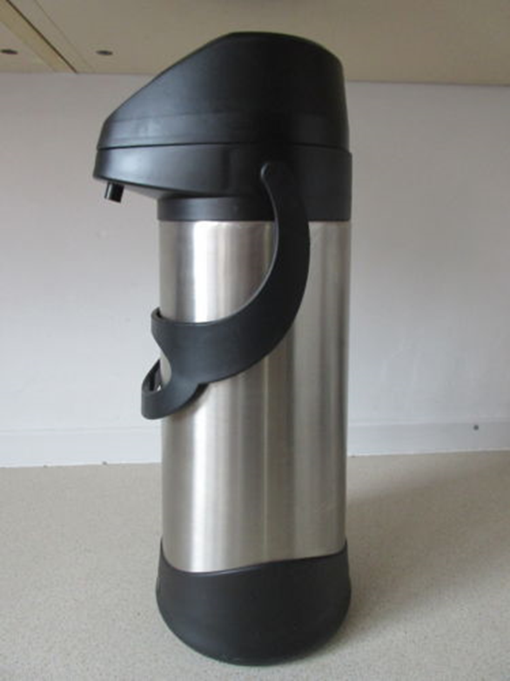
Liquids
- Fill the thermos up with hot water (boil the bottled water) in the first two hours. This will ensure you have a ready supply at all times to enable feeds to be prepared quickly. If you suffer with sea sickness, the cabin is the worst place to be, so this will minimise the need to be inside.

CNP (Regular feeds) [DELETE IF USING UCAN
- Fill to 1st line with energy drink and then top up to 2nd with hot water from thermos. Check the temperature to make sure it is not too hot.
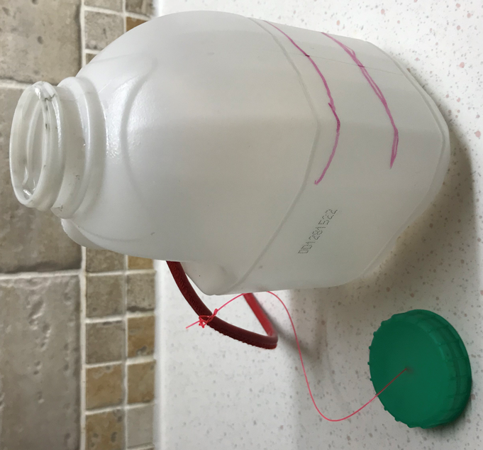
- If I am sick on the next feed use warm water and continue to use this until I have kept a feed down. If this doesn’t work, we try flat coke.
- Please note, that I could do the whole swim on water if necessary. Hydration is more important than calories.
- If I need a boost of energy, you can add extra scoops of CNP to the mix. There’s no maximum concentration, though it may cause sickness or diarrhea, so a really thick feed is a good final resort but would advise to avoid this too soon!
- I will have mixed [3 litres] of double strength CNP. See guide for mixing additional CNP.
- It’s good to have a break from CNP every four-six hours or so, electrolytes provide this break. If you want another break, black tea is a good alternative. At this feed please use [black tea / black coffee / squash]

SWIM
Feeding Instructions – These are the most important pages! [Crew 1] to lead but [Crew 2] can provide support / advice

UCAN (Regular feeds) DELETE IF USING CNP
- UCAN can dehydrate, so should only be used every other feed. Fill to 1st line with UCAN and then top up to 2nd with hot water from thermos. Check the temperature to make sure it is not too hot.
- On alternate feeds please use [Black tea / squash]
- This feed works by promoting fat burning. This process is disrupted if an energy spike is given via solids or a CNP feed, so both should be used sparingly / saved for when a spike in energy is required.
- If I am sick on the next feed use warm water and continue to use this until I have kept a feed down.
- UCAN can be mixed by adding four scoops of UCAN to a shaker bottle of bottled water to make double strength feed. This will last for several feeds.
- If I do need a significant energy boost, a CNP feed can be provided – this is a quick acting carbohydrate. See mixing guide.

Solids / treats
- Solids take a lot of time and, therefore, should be used sparingly. As a treat they can give a massive psychological boost if unexpected and very occasional.
- Please pass any solids to me hand to hand or in a cup attached to a carabiner / feeding reel.
- Please don’t be offended if I reject a treat!
- I must consume something solid if I take ibuprofen.

SWIM
Feeding Instructions – These are the most important pages! [Crew 1] to lead but [Crew 2] can provide support / advice

Electrolytes
- Complete this first step with the previous feed as it takes a while for the tablet to completely dissolve.
- Fill to 1st line with cold water and add half a tablet – let it dissolve (stop fizzing)
- Top up with hot water just before the feed as you would with the other feeds.
- I will have electrolytes instead of a regular feed every 5 hours

Pain killers / medication
- I will only take pain killers if I need them, I will let you know at a feed that I want them next time.
- I have paracetamol and ibuprofen on board [edit if you have other options]. Paracetamol should be used first.
- Please ensure that I stay within the daily limits:
  - Paracetamol: no more than 8 tablets in 24 hours, so two can be taken every 4-6 hours
  - Ibuprofen: no more than 6 tables in 24 hours, two can be take every 4-8 hours.
- Pass me the tablets before my liquid feed.
- If I take ibuprofen, I must also have something solid to eat.
- [I will need lansoprazole / omeprazole if I have ibuprofen and after 10 hours to prevent reflux]
- Remember: it’s just one day!
- I am already taking once a day antihistamine so I will not need any more during the swim even if I get stung / If I get stung, I can take one of the antihistamines in the first aid kit. [delete as appropriate]

SWIM
Feeding schedule (CNP)

Actual Time | Stopwatch | Liquids | Solids | Status  (use this to decide if you need to adapt next feed or provide treat)
 | 01:00 | No feed
 | 02:00 | 300ml CNP
 | 03:00 | 300ml CNP
 | 04:00 | 300ml CNP (and prep below)
 | 05:00 | 300ml High5 Zero
 | 06:00 | 300ml CNP
 | 07:00 | 300ml CNP
 | 08:00 | 300ml CNP
 | 09:00 | 300ml CNP (and prep below)
 | 10:00 | 300ml High5 Zero
 | 11:00 | 300ml CNP (and prep below)
 | 12:00 | Black tea
 | 13:00 | 300ml CNP
 | 14:00 | 300ml CNP (and prep below)
 | 15:00 | 300ml High5 Zero
 | 16:00 | 300ml CNP
 | 17:00 onwards | Follow pattern above: CNP hourly, electrolyte every 5 hours, black tea every 12 hours

SWIM
Feeding schedule (UCAN)

Actual Time | Stopwatch | Liquids | Solids | Status  (use this to decide if you need to adapt next feed or provide treat)
 | 01:00 | No feed
 | 02:00 | 300ml UCAN (and prep below)
 | 03:00 | 300ml Black tea
 | 04:00 | 300ml UCAN (and prep below)
 | 05:00 | 300ml High5 Zero
 | 06:00 | 300ml UCAN (and prep below)
 | 07:00 | 300ml Black tea
 | 08:00 | 300ml UCAN
 | 09:00 | 300ml sugar free squash (and prep below)
 | 10:00 | 300ml High5 Zero
 | 11:00 | 300ml UCAN (and prep below)
 | 12:00 | Black tea
 | 13:00 | 300ml UCAN
 | 14:00 | 300ml sugar free squash (and prep below)
 | 15:00 | 300ml High5 Zero
 | 16:00 | 300ml UCAN
 | 17:00 onwards | UCAN every 2 hours, alternate hours swap between black tea and sugar free squash. Electrolyte every 5 hours

SWIM
Mixing CNP

I will have spare CNP on board the boat in case:
- You need to mix some more
- You need to add extra scoops to the existing mix

Instructions
- Take a marked jug and fill it with water to the 1 litre line
- Add 8 scoops of CNP to make it double strength (it mixes easier if you whisk as the CNP is added)
- Add flavouring (e.g. vimto squash or summer fruits) or leave it plan if you intend to flavour with tea or coffee
- Use the funnel to pour it into a 1.5 litre bottle.

Adding extra scoops
There’s no limit to how much extra CNP can be added. I’ve seen it as thick as wallpaper paste before now. I wouldn’t recommend very strong CNP for extended periods.

There can be gastric related implications of extra feeds which are fine if they mean success rather than failure. Just be aware that there may be sickness in the water or after the swim is complete or alternatively diarrhoea. This is normal, it will pass!

Dehydration
If I say that I’m unable to pee, then there are number of things that can be tried – tea is a good diuretic. Alternatively, more frequent feeding for a while or for the rest of the swim.

SWIM
Communication - between me and crew

- In the water it is difficult to hear. The engine is noisy, and I have earplugs
- I will provide laminated boards and white board [check with your pilot, some really don’t like white boards!] and pens so you can communicate with me.
- We will use coloured signal cards.
- You will also have a whistle to get my attention.
- I will acknowledge all signals with a thumbs up.
- What I need to know in the water:
  - When there is some danger (e.g. an object in the water that I need to swim around – I will swim through jellyfish)
Support swimmer is getting in / out of the water in 5 mins
  - An indication of when it is 5 minutes before a feed
Feed in 5 Mins
  - When there is a need for me to speed up – e.g. to get across a particular part of the tide
  - When Support Swimmer is about to get in (though this should always be by prior agreement)
Swim Fast (this generally comes from the pilot)
  - When it is my last feed (if you know for certain)
- I do not need to know:
  - How long I have been swimming
  - Where I am
  - How much further / how far I’ve swum
Stop (if there is danger ahead)

SWIM
Communication – Things I might ask for or do

- Thumbs Up - I will acknowledge all communications with a thumbs up.
- How far/ long – DO NOT tell me times or distances no matter how much I ask. With the pilot’s guidance you can tell me when I have had my last feed.
- I need a support swimmer – If I start struggling, I may request [Crew 2] to get in. Check with the observer first to make sure he is allowed – it would also be great to have him swim into France with me so this needs to be factored into timings later in the swim.
- I want the support swimmer to get out – if for any reason the support swimmer isn’t working for me I will ask them to get out. This is about me and not them, I’m sure they have been doing a great job. Please note, not all swimmers like having support swimmers and some think they will and later realise that they don’t, it’s your swim, you can ask your support swimmer to get out if it’s not working for you.
- Random questions – I am not really one for mind games but may be thinking about all sorts of things. If I start asking questions like what city begins with K or who sang a particular song this would be why – it does not mean I have lost the plot!
- Goggle change/ new ear plugs / new cap / more Vaseline – Probably the most important request. They will all be in my crate and I will go through with you all beforehand. All things will need to be handed down in a cup or on a carabiner. For Vaseline, I may ask for a flannel to wipe off any excess on my hands.
- Feeds – Whilst the feed plan is laid out, things can change. I may decide I want/ need something else. If I do, I will try and tell you at the previous feed or at least before the 5 minute warning so you have time to prepare.

SWIM
Communication – Things I might ask for or do

- Toilet – I can generally pee whilst swimming. If I need to stop, I will give you a W sign with my hands. To date I have not needed to do more than pee but you never know. If I look at you and clench both fists you know it’s time to look away.
- Shout abuse – You generally go through quite an emotional journey on long swims with some low points. I am told you get paranoid about what is happening / being said on the boat which all adds to this. I apologise in advance and caveat that anything said whilst swimming is not meant – if I do start shouting or swearing at you it will most likely be about something else and I am just taking it out on you – All I can do is apologise and promise to buy you a beer back in Dover.

SWIM
Communication – with the wider world

- I CAN SEE messages on a white board. Try to restrict the use of the whiteboard to feeding times or if I look low about halfway between feeds. As much as I want the messages and love I do not want to waste too much time stopping to read them. [Crew 2] to control whiteboard. Please check with pilot on their preferences on white boards.
- Any words of encouragement / BANTER FROM THE SUPPORT CREW ARE WELCOME. You know me well enough to know when I need banter and when I need support. As above though restrict it times when I have stopped to feed. Please remember that it can be hard to hear with ear plugs and it can be very confusing. Try and remember to have only one person speaking at at time.

Social Media
[The use of social media is a very personal thing. Make sure you do what is right for you, there will always be interest in what you’re doing. Updates can add pressure or add support. Work out what is right for you.]
My recommendation would be to remain quiet until the swim has started, the last thing you want is your phone pinging relentlessly when you’re trying to get your last bits of rest before the big day. You will still need to pay attention to your phone in case your pilot tries to get hold of you.
- Facebook – [Crew 2] can post messages / photos / videos / screenshots of tracker as the day progresses. I will give you access to my account and please also tag “xxxx any facebook page”.
- Twitter – [Crew 2] As above, tag @twittertag. Twitter can be less frequent.
- WhatsApp – [Crew 2] The group consists of family, friends and others who are interested. Please provide updates, engage with questions and banter and share key messages on the whiteboard.

SWIM
Communication – with the wider world

Should things go wrong, your attention needs to be on me and my safety / wellbeing. There will be lots of requests for updates and these can wait. If the swim is called by me or the pilot for any reason, please check with me before doing any social media updates. The only exceptions to this are [NAME ANY IMPORTANT FRIENDS / FAMILY]

Photography & Videos – [Crew 3] will capture lots of the swim, what is happening on the boat etc which is predominately for editing and sharing after the event. [Crew 2], I suggest for social media you just use your (or my) phone, so make sure you have a charger. [Crew 3] – I will also leave you in charge of the GoPro.

SWIM
Support swimmer – [Crew 2]

- The support swimmer must not enter the water without the Pilot’s consent. As the support swimmer has not necessarily been through the same rigour of a medical and qualifying swim, the pilot may request that any support swimmers sign a liability release before allowing them into the water. This is for their legal protection
- The rules are very simple:
  - CSA: No support swimmer until 2 hours have elapsed. Then for a maximum of an hour at a time. There must be an hour gap between support swims.
  - CS&PF: No support swimmer until 3 hours have elapsed. Then for a maximum of an hour at a time. There must be two hours between support swims.
  - No pace-making allowed. The support swimmer must swim alongside and not in front of the me.
  - Only one swimmer at a time (exceptions are sometimes made for the finish)
  - No contact is allowed
  - Support swimmers can wear whatever they want including wetsuits & fins.

- [Crew 3] Please help [Crew 2] with anything he / she needs getting in or out.

- My current thinking is that [Crew 2] joins me as below although we can change this on the day if needed:
  - @ 5 hours
  - @ 9 hours
  - @ last hour

SWIM
What if it all goes wrong?
- The success rate for a channel swim is approximately 70%. I have prepared well and therefore have high hopes for a successful outcome, and yet we should also talk about the potential for things not going well.
- All sorts of things can happen outside of our control, including: a deterioration in the weather, fog, tides not behaving as predicted, ….. the list goes on
- On top of this there can be medical issues such as SIPE, hypothermia or injury.
- The channel will always be there, and my long-term health should always be more important than risking continuing when I should stop. If you are in any doubt, please check with the pilot, they will have the ultimate say if the swim is to be aborted against my will.
- There may be times when I look dreadful and your natural tendency will be to stop the swim, often I can get through these difficult patches, the pilot will have seen all of this before, please do check with them if you are concerned.

Often more difficult are mental implosions. Watch out for mood changes. These can pass. I may beg to get out, I may even cry. You can use any means, fair or otherwise to just keep me going. If we do that for long enough the dark moments can pass. Some tactics that are worth trying are:
- Treats
- Pass on messages
- Support swimmer
- Take the boat away!
- Ignore me!
- Remind me that it is just one day and be truthful about any positives in the swim
- Whatever it takes!!

POST SWIM
The End

- [Crew 2] will be in for the final push with me. When we get close to the shore the main boat will stop and a rib / kayak [check arrangements with your pilot] will come in with me. [Crew 3] will come in the rib to capture “that moment”
- Once in France I have to clear the water (on the beach or rocks) and the hooter is sounded – If we land at a vertical cliff face I just need to touch it. [Crew 2] do not touch me until the hooter has been sounded.
- From shore [Crew 2] will need to swim back to the boat. I will either swim back or go back in the rib [check arrangements with your pilot].
- The boat will then take us back to Dover which will take approximately 3 hours. [Crew 1] please call [Name important friends & family and let them know that I have landed and am safe and well. Ask [Pilot] for ETA back in Dover and let them know
- [Crew 1] – When I get back on the boat please help me get some warm clothes on and my wet trunks off. It would also be good to have a hot [tea / coffee / hot chocolate] ready in my drinking flask
  - Dry off and swimsuit off
  - Add layers covering the core first until they are all on.
  - Socks and shoes can wait, so can hat & goggles
  - Make sure swimcap is replaced by woolly hat, goggles and earplugs off at this point.
  - Dryrobe on top of everything else. Note, if you use this to change under, it’s worth doing so inside out so that it can be turned back the right way to keep me warm later.
  - Dryrobe back over the top. My gloves will be in the pocket if I need them
- If the swim is unsuccessful, the routine back on the boat is the same and even more important, particularly if the swim has been stopped on medical grounds. Social media can wait.

POST SWIM
The End
- We will need to take all our bags & crates off the boat at the end. I would appreciate all crew helping with this aspect.

- When we get back we can head back to the hotel and then depending on time and fatigue levels head for a beer and dinner!

- I will accept the need for medical attention if recommended (even if I think I know better on the day).

